The Primitive Methodists
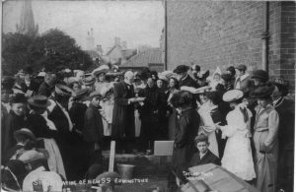
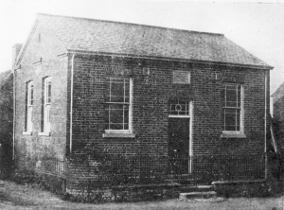
The Primitive Methodists who were known as the ‘Ranters’ were established in Edwinstowe around 1816-7 and their chapel was opened in 1848 (in the same year as the Wesleyan Chapel) on the corner of Friend Lane near the railway station opposite the Dukeries Hotel. It was ‘a small, but clean and comfortable structure, with rising pews. Behind the tiny communion rail stood a high tub-shaped pulpit, fitted with two imposing paraffin lamps.’ According to the Religious Census of Edwinstowe and Thoresby taken in 1851, the congregation was recorded as 55 (afternoon) and 110 (evening). Space free 50, other 110, standing 30. Their approach to new building differed from the Wesleyan Methodists who tended to wait until they had the majority of funds before starting a new project. The Primitive Methodists in the circuit sometimes held outdoor camps, weeknight meetings and even allowed women preachers.

We have a report by T.F. from the Primitive Methodist Magazine 1862 about the Chapel Anniversary: “On the Lord’s Day, October 6th, 1861, two sermons were preached to crowded congregations, in the Primitive Methodist chapel at Edwinstowe by the Reverend G. Watson of Gainsborough.

On Monday the 7th, tea was given by Mesdames Charlton, Anderson, Fells, Freeman and Willmot. At the public meeting which followed, the chair was occupied by our Friend Mr James Lucas. After a short speech by Brother Masling, Brother Anderson gave us a brief historic account of the chapel funds, and the various plans which had been adopted in order to lessen the debt, and bring it into the neat, clean and respectable condition it now presents. The writer and Mr Watson subsequently addressed the meeting. The net proceeds of the anniversary amounted to £5.2s.10d.”

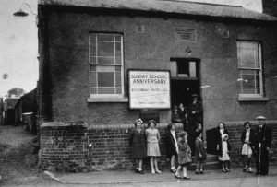

In 1923, the Primitive Methodist Leader reported that, “Edwinstowe School Anniversary took place on July 1st. The conductor in the afternoon was Mrs F.J. Pennock and Reverend F.J. Pennock in the evening. The children sang and recited special pieces. Large congregations were present, and the effort was a pleasing success. Finances good.”

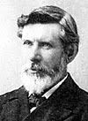
The best-known visiting preacher was Reverend James Flanagan (1851-1918). As a Town Missionary and advocate of home missions, he had made many converts amongst the desperately poor inhabitants of Nottingham’s notorious Narrow Marsh and other slums. By 1887 the Albert Hall in Nottingham was filled on Sunday nights with people eager to hear him. ‘Ministers slipped into churches to hear him preach, and many of them proclaimed him chief for they were held spellbound by his eloquence.’

His father was a Irish pipe-maker with a weakness for drink. He died young leaving James’ mother to raise at least six children. Working as a coal miner, James had taken to ‘evil ways’. However, when he was 21 years old he attended a service at the Primitive Methodist Chapel in Ilkeston and was converted. He immediately set about learning to read and write, studying late into the night. Desperate to hear Charles Spurgeon’s inspirational preaching, having worked a 14-hour shift, James set off on foot. The hall was already full, but when he told a steward that he had to walk 18 miles and start work at 4 am, he took pity and smuggled him into a remote corner.
Joining a mission band, he learned how to give his testimony becoming a lay preacher and conducting short missions. James Flanagan’s ‘name rapidly became familiar in the homes of the people and invariably the simple, well-known portrait-poster to which was added, ‘Flanagan is coming’ was sufficient advertisement to secure a crowded chapel or well-filled hall.’
His mother, Elizabeth Robinson, was born in Edwinstowe in 1821, the youngest of five children. In 1827, within a few days they had lost both their parents, Richard and Isabella, to typhoid. The family had worked at Thoresby Hall for Earl Manvers for 40 years. Elizabeth had happy memories of Edwinstowe and spoke ‘with pardonable pride of the manner her father’s character had impressed the big folk at the Hall.....The day of the funeral, the solemn procession, the crowded village street....’

Flanagan came to Edwinstowe on a fortnight’s mission. On arrival, although his hosts Mr. and Mrs. Freeman said, “the tea is ready, come and take a meal. You can visit the church afterward.” He answered, “Thank you; no, that churchyard is a sacred spot to me, I must go there first”. He continues, ‘Leaving the house I wended my way to the upper end of the village to the old church, which for the size of the place, was a fine structure. The church and churchyard being elevated above the rest of the roadway, I passed through the swing-gate and ascended the few stone steps which opened on the pathway leading to the church door.’ Asking the old Sexton to follow him, he made his way to the left side of the church, ‘coming on a quiet corner near the hedge which divided the churchyard from the vicarage garden. There, in a shady spot were two graves.’ He immediately knelt down beside his grandparents’ joint grave and prayed that ‘as he had heard my former petition to open the way that I may preach The Gospel where my mother was born, he would so qualify me for the work that the mission should not be forgotten.’ It certainly proved unforgettable! ‘The little chapel became too small to hold the people who wished to be converted. The Wesleyan friends threw open their doors,....even in the public-houses, the one theme was salvation.’ (Primitive Methodist Magazine 1901).
Flanagan claimed that during 8 years he travelled 90,500 miles; preached 1,000 sermons; gave 600 lectures and raised around £20,000 for work in SE London slums.
He was sent on missions to New Zealand, Australia and South Africa. He is commemorated at St George’s Hall, Nottingham. When it opened in 1900 he had raised £12,500 for the building fund. (see Nottinghamshire Historian Spring/Summer 2004 pp 9-11 Peter Hammond Reverend James Flanagan)
In 1948, both Methodist churches celebrated their centenary. Due to diminishing attendance, in 1951, the Primitive Methodists merged with the Wesleyan Methodists. After the final service in the Friend Lane chapel, the congregation paraded through the village to the Methodist Church where another service was held followed by a tea for the combined congregations. Official posts were divided between the two churches. Mr. S.L. Winfield who tenanted the farm next to the former Primitive Methodist Chapel used it to store his farm equipment. It gradually fell into disrepair and was demolished in 1986.

