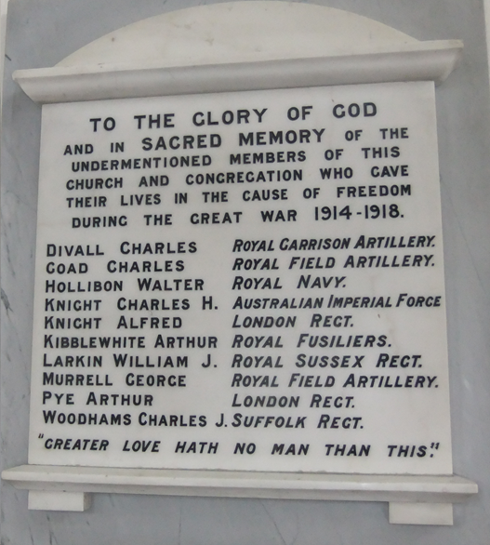
Charles Divall – was born in Hailsham in February 1893 the son of Emma Divall. He was baptised in Hailsham Parish church on February 1894. By 1901 Charles, together with his brother and sister were living with their mother who was a widow. He attended Hailsham Boys School in Battle Road, Hailsham. By 1911 Charles was living and working in Eastbourne as a gardener. He enlisted in September 1915 and his address was given as 12 Battle Road, Hailsham. In February 1916 he went with his regiment, 1st Garrison Battalion the Bedfordshire regiment to India. On 28 February 1917 he was admitted to hospital in Delhi with a fistula and shortly afterwards he had an operation. He was later diagnosed as having TB. On 17 August 1917 he was declared unfit for further service and returned to England. On 16 March 1918 the Medical Board agreed that his disability was “caused by service during the present war.” He was awarded a pension and discharged. He died on 5 January 1919 at his home in Battle Road and is buried in Hailsham cemetery in one of the ten WW1 graves maintained by the Commonwealth War graves Commission.
Charles Goad – was born in Hailsham 1894 son of George & Harriett Goad. Raised in the town and educated at Hailsham Boys School. The 1911 census records that Charles, then aged 17, was working as a carman for a coal merchants whilst living with his parents plus 3 brothers and 2 sisters. He enlisted in 1915 at the Hailsham recruiting Office and joined the Royal Horse/Field Artillery. Charles served in France as a driver and later in the Balkans. He died in Salonika on 2 October 1918 possibly from a flu epidemic which was prevalent at that time. He is buried in Kirechkoi-Hortakoi Cemetery, which is about 10 miles north east of Thessaloniki.
(Henry) Walter Hollibon(e) – was born in Hailsham on 26 December 1893 the son of Charles & Caroline Hollibone. He was educated at Hailsham Boys School after which he worked at Burfield & Son, Ropemakers. He had two sisters and one brother, Charles who also lost his life in the war. Walter enlisted on 27 November 1911 and served as a Gunner in the Royal Horse Artillery. He went to France in August 1914 where he was later promoted to Bombardier. He was discharged with exemplary character in March 1916 and transferred to the Army Reserve. During his time in the army he married Frances and they set up home in Coombe near Sandwich, Kent. It seems he did not settle and later joined the Royal navy where he served as an Ordinary Seaman on HMS Laforey. On 25 March 1917 the ship was on convoy duties in the English Channel when it struck a mine and sunk. Walter lost his life on that day. He was aged 23 years.
Charles H Knight – was born in Hailsham in 1883 the son of Ambrose & Mary Ann Knight. Ambrose was a butcher. After leaving Hailsham Boys School, Charles worked as a grocer’s assistant. However by 1911 he was living in Lyminge near Folkestone where he was working as a self-employed grocer. He subsequently emigrated to Western Australia where it is recorded that he had married Dorothy. Charles enlisted in the Australian Infantry where he rose to the rank of Corporal. He was killed in action on 27 September 1917 aged 34. His death is recorded on the Menin Gate Memorial, Ypres, Belgium.
Alfred Knight - was born in Hailsham in 1887 and was the brother of Charles Knight (above). After leaving Hailsham Boys School, Alfred worked as a telegraph messenger and later as a postman. He enlisted in the London Regiment as a Rifleman in the 8th Battalion Post Office Rifles. He was wounded whilst serving in France and later died or his wounds on 31 January 1918. He is buried art Bur Rocquiney Equancourt Road British Cenetery, Manancourt.
Arthur Kibblewhite – was born in Hailsham in 1894. He was the son of Arthur and Flora Kibblewhite. The family lived at 15 North Street although they moved at some point to no.17. Arthur had one sister. Arthur attended Hailsham Boys School. On leaving school he worked as a milk boy and later as a blacksmith. He was member of the Hailsham Brotherhood. Although he was living at home at the start of the war he enlisted at the Hastings Recruiting Office from where he joined the Royal Sussex Regiment. He later transferred to the Royal Fusiliers. He was sent to France in 1916 where he was both wounded and gassed. Initially he was posted as missing on 21 August but two months later he was confirmed has having been killed on that date. He was aged 24. He was buried at Achiet Le grand Communal Cemetery Extension, Pas de Calais. The photograph below confirmed that Arthur was an active member of Hailsham Wesleyan Church. His service was recognised by the awards of the British and Victory Medals.
William J Larkin – was born in Shoreham in 1890 the son of William and Agnes Larkin. The family moved at some point after William’s birth to Malling, Kent where William’s father worked as a coachman. William enlisted at the Brighton Recruiting Office and joined the 12th Battalion Royal Sussex Regiment. He was killed in action at the Battle of the Somme at the age of 26. He is buried in the Euston Road Cemetery, Colincamps, France. His name is included on the Rottingdean War Memorial. Although William is included on the Wesleyan Memorial it is unclear what his connection is with the town and with the church. Neither he or his family were included on any of the Census returns for Hailsham (1891;1901;1911). However Larkins the saddlers were a well established business with premises in the High Street and it is possible William was related to Richard and Thomas Larkin and spent some time working with them.
George Murrell – was born in Iden, Kent in 1896 the son of William and Catherine Murell. When George was five the family moved to Harebeating Farm, Hailsham. William was employed as a bricklayer. George was educated at Hailsham Boys School. He also attended the Sunday school at the Wesleyan Church. By the age of 15 George was working as a milk carrier after which he worked for Mr W H Lawrence, a grocer in Hailsham. He joined the Territorials before the war broke out. He was also a member of the Brotherhood. In November 1911 George enlisted into the Sussex Battery, 8th Home Counties Brigade Royal Field Artillery. He signed on for four years giving his age as 17 years and 2 months. In fact he was two years younger. George was just 5ft 2½ ins tall. George signed on as a driver and by January 1913 had attained the rank of Acting Corporal. In 1914 he was posted to India and promoted to the rank of Bombardier and later as Acting Sergeant. In April 1916 he was diagnosed as having tuberculosis and was returned to England on a hospital ship. He was later discharged with a very good character reference and awarded a pension. He had intended to return home to live with his mother in Hailsham and work as a grocer’s assistant. However at his medical review held in March 1917 it was reported that he had not worked since his discharge and had been unable to return to his former employer. George died in Hailsham on 17 October 1917 aged 21 years and was buried in Hailsham Cemetery.
Arthur Pye – was born in Westerham, Kent in 1891, the son of Arthur Edwin and Louisa Pye. By 1901 the family had moved to Hailsham and were living at 20 High Street where Arthur snr operated his shop and business as a leather merchant and shoe seller. The family continued to live in their High Street home and Arthur attended Hailsham Boys School. By 1911 Arthur was lodging in Southend-on-Sea where he was working as an accounts clerk for the Southend Waterworks Co. Arthur subsequently married Ethel and they had a son, Reginald. Arthur enlisted in the Sun Street Recruiting Office in London and joined the London Regiment where he served as a Private. At that time he gave his address as Burchetts Farm, Whitesmith, Halland which is a few miles north of Hailsham. Arthur was killed in action at the Battle of the Somme on 7 October 1916. He was aged 26 years. He is buried in Warlencourt Cemetery in the Pas de Calais. As with most of the men in the Wesleyan memorial their actual involvement with the church is unclear. However in the case of Arthur it seems likely that he was an active member, certainly in his younger days before he moved to Southend. His parents were certainly leading members of the church and Arthur snr was a trustee.
Charles Woodhams – was born in 1896 in Hellingly, the son of Albert and Anne Woodhams. Although know as Charles his actual name was Albert John Woodhams! He was educated at Hailsham Boys School. Charles had at least one brother and three sisters. By the age of 15 Charles was working for a farmer as a milkman. He enlisted in August 1916 at the Eastbourne Recruiting Office and joined the Suffolk Regiment where he served as a Private in the 2nd Battalion. He was sent to France in December 1916 He was twice wounded in action and sent back home on both occasions. However he was wounded for a third time and admitted unconscious to hospital suffering from head wounds. He died from his wound #s a few hours later aged 23 years. He was buried the Sunken Road Cemetery, Boisleux-St Narc, Calais.
Acknowledgements – much of this information has been taken from “The Heroes of Hailsham” by David Dyer (2011)
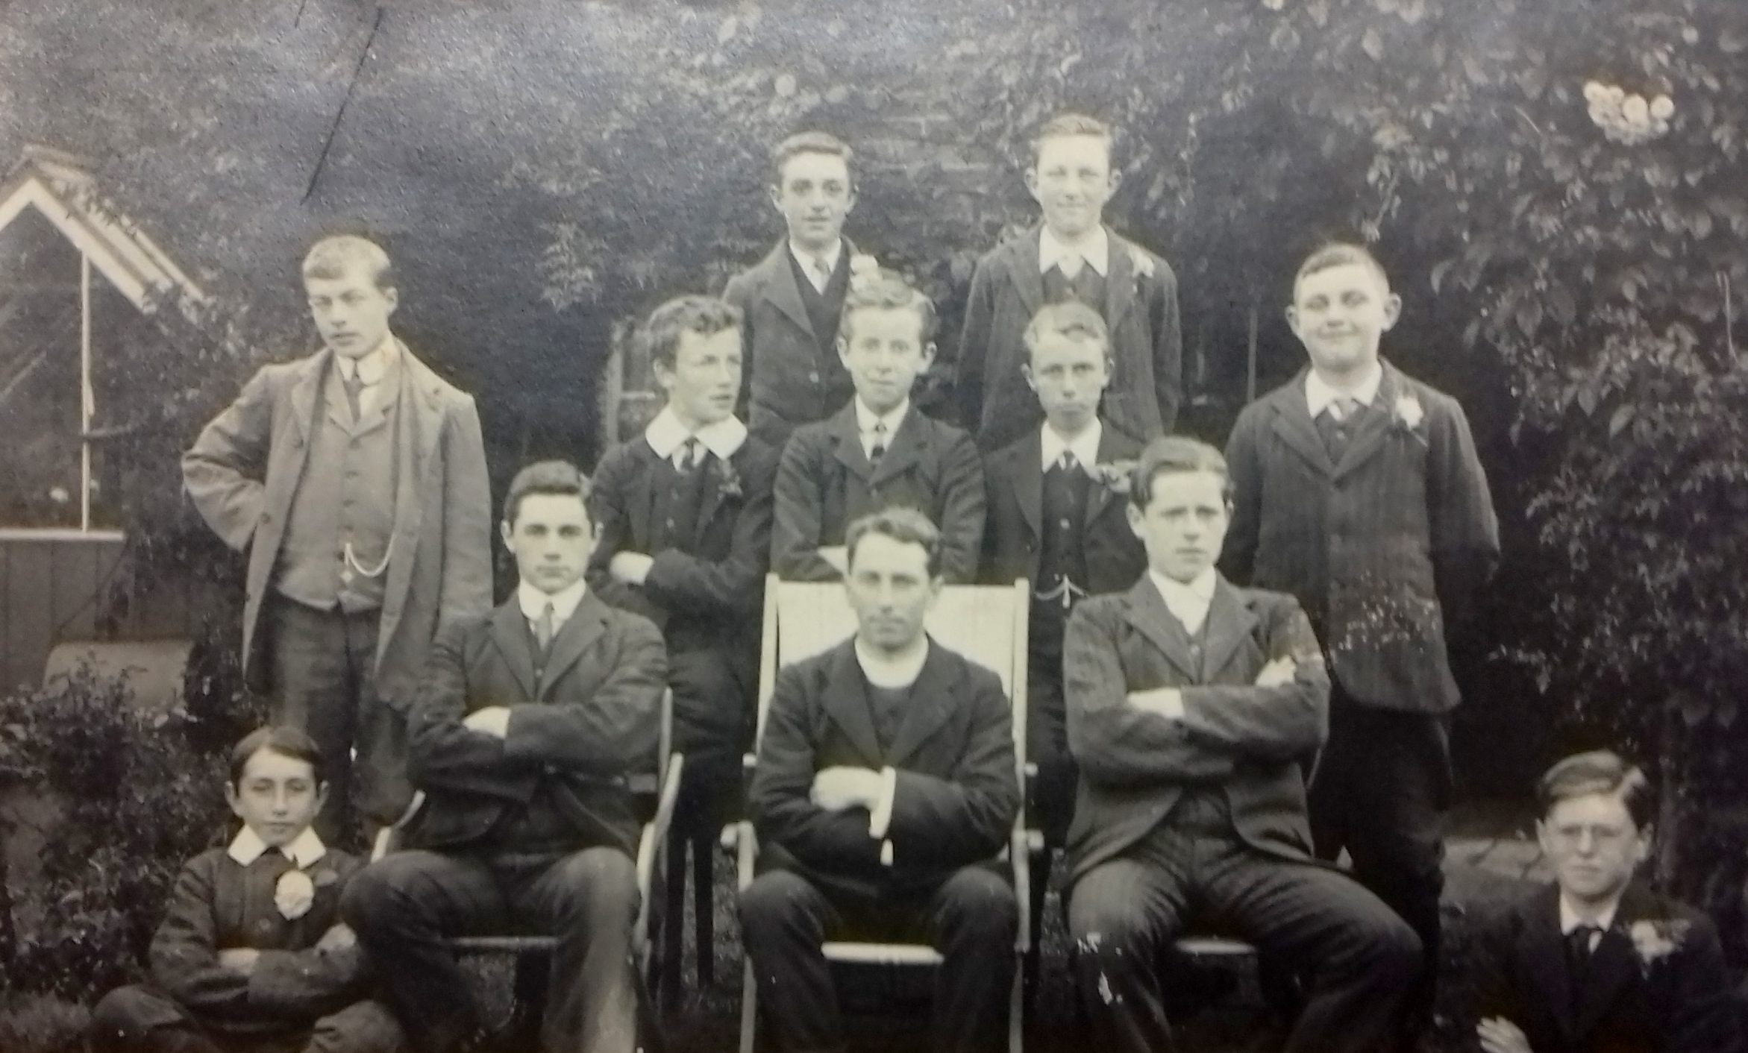
Arthur Kibblewhite standing extreme left (in grey jacket). Taken about 1911
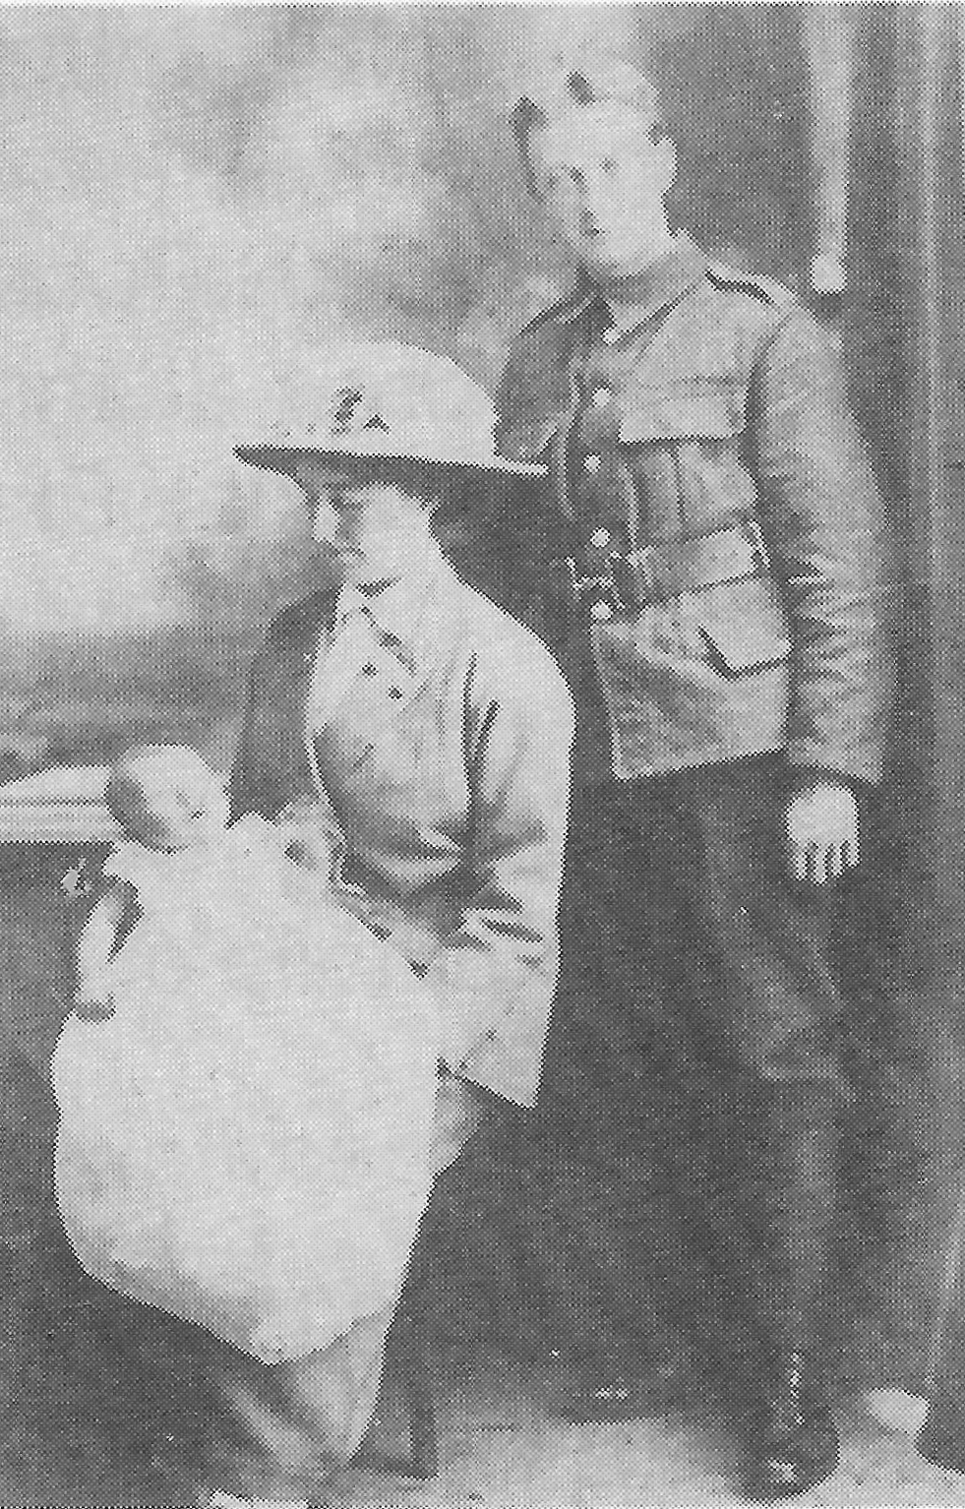
Arthur & Ethel Pye with baby Reginald

