Before

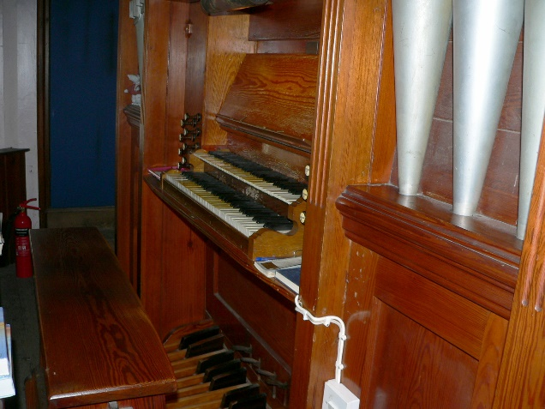
The two manuals and pedals

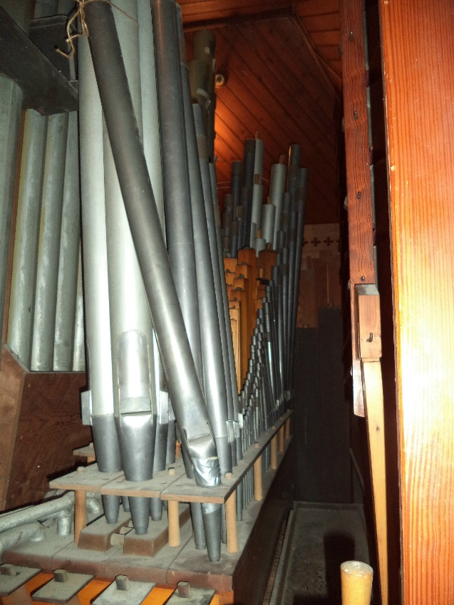
Some damaged pipework

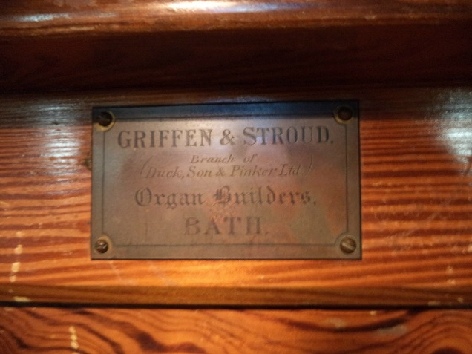
The builder’s plaque

During

Dismantling, removing pipework, removing Bourdon for cleaning etc.
on 14 March 2019

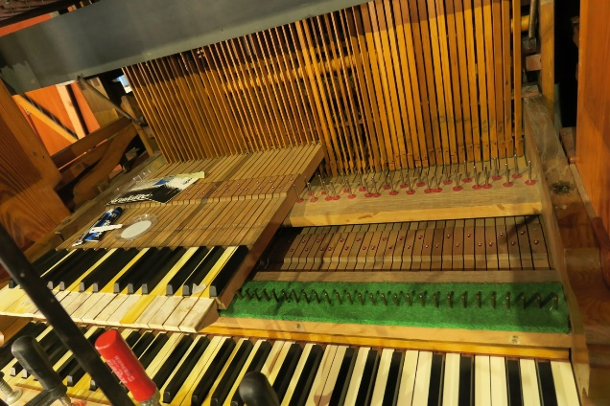
Partial removal of keys for repair and cleaning

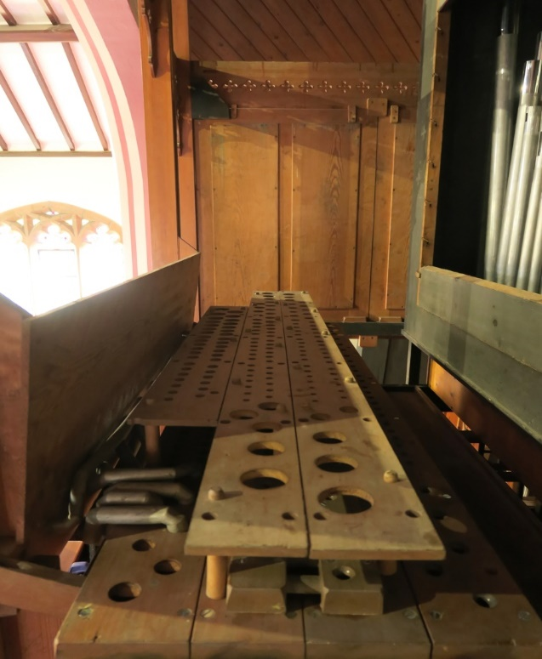
Removed pipes and damaged pipes on left

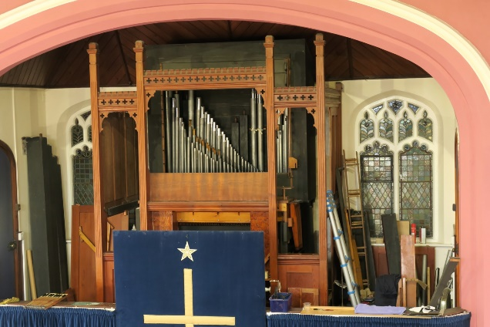
General view with removed pipes

During
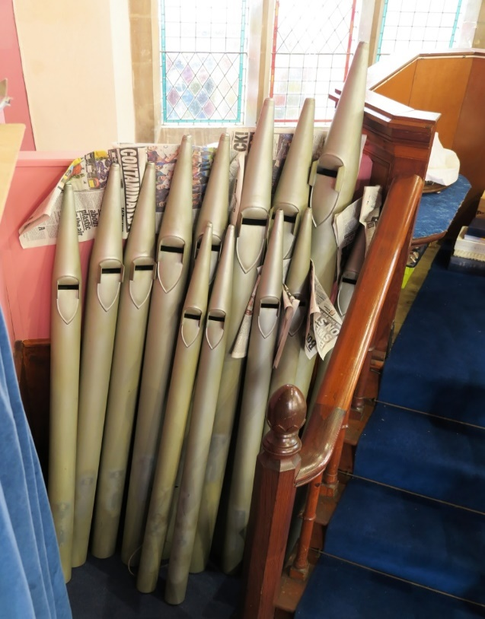
Removed pipes for cleaning or repair

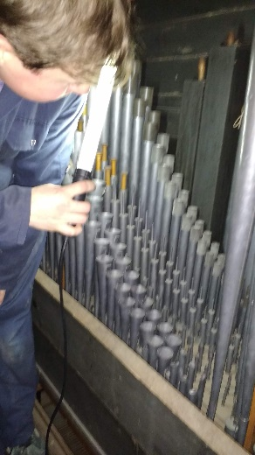
Alistair Curtis working on the memorial organ

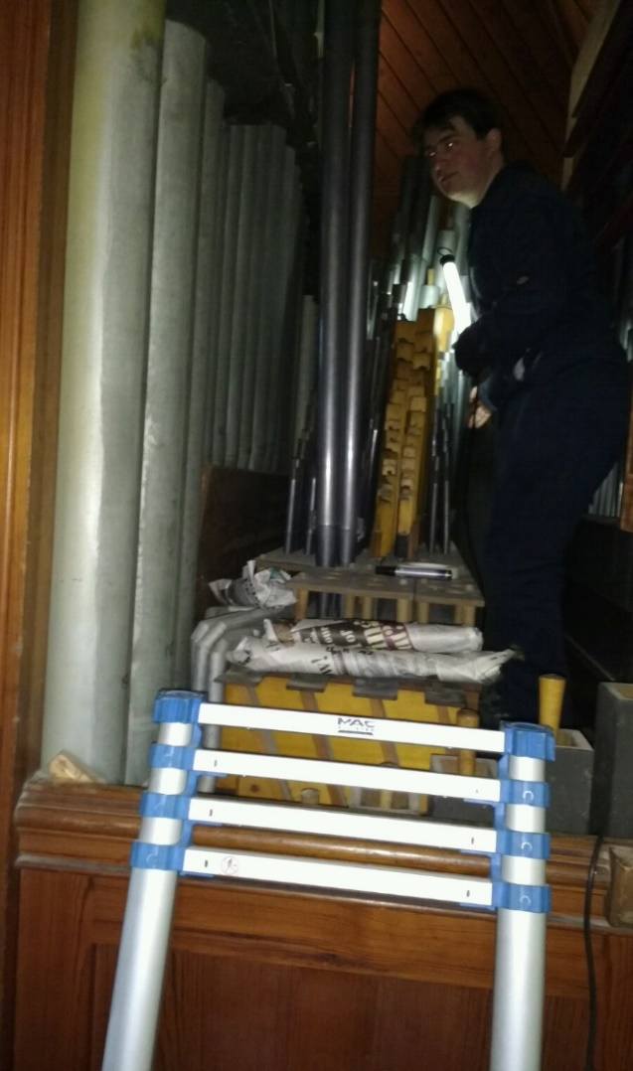

After

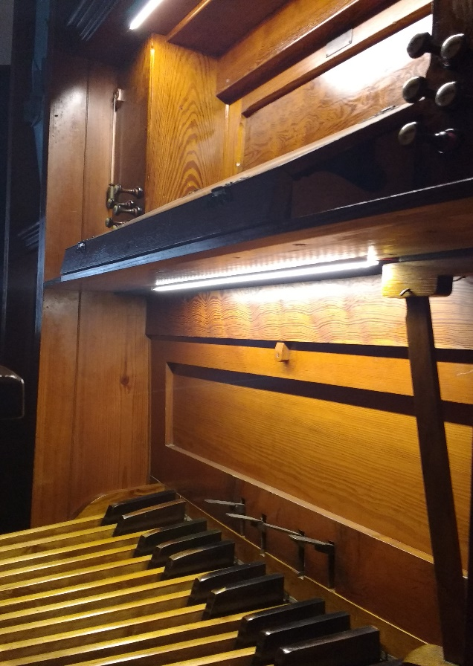
Updated electric lighting

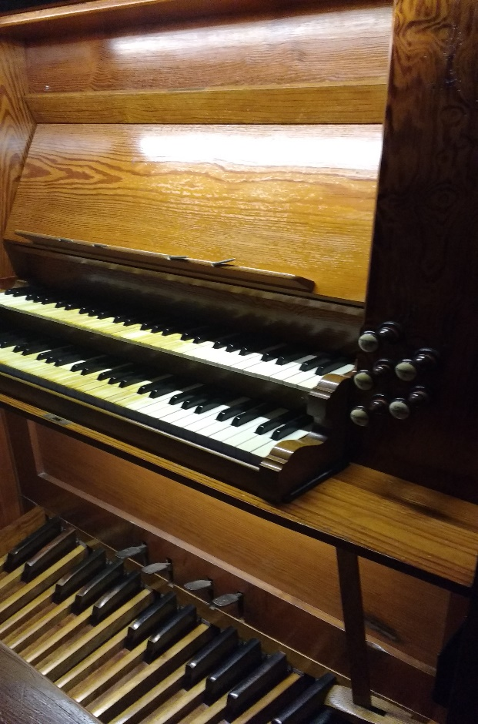
Restored manuals and bourdon

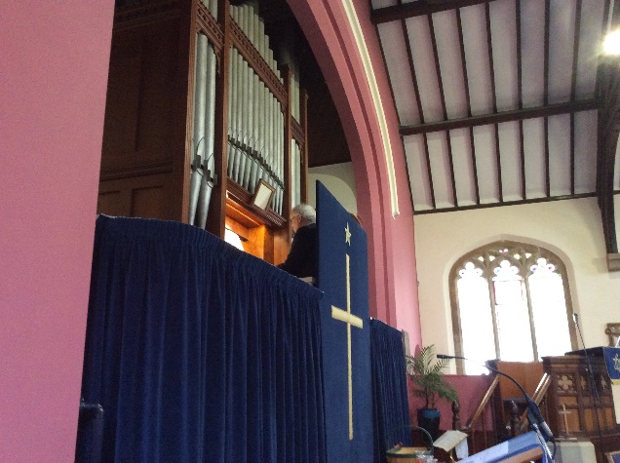
Dr David Flood of Canterbury Cathedral at
Rededication Service 13 November 2019

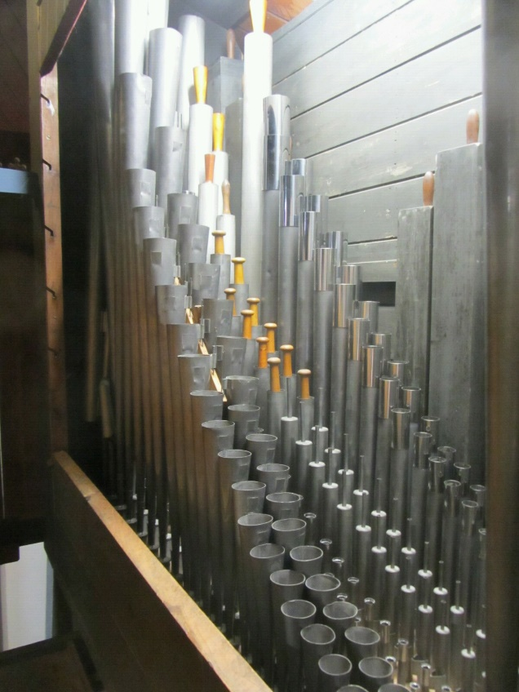
Some completed pipework

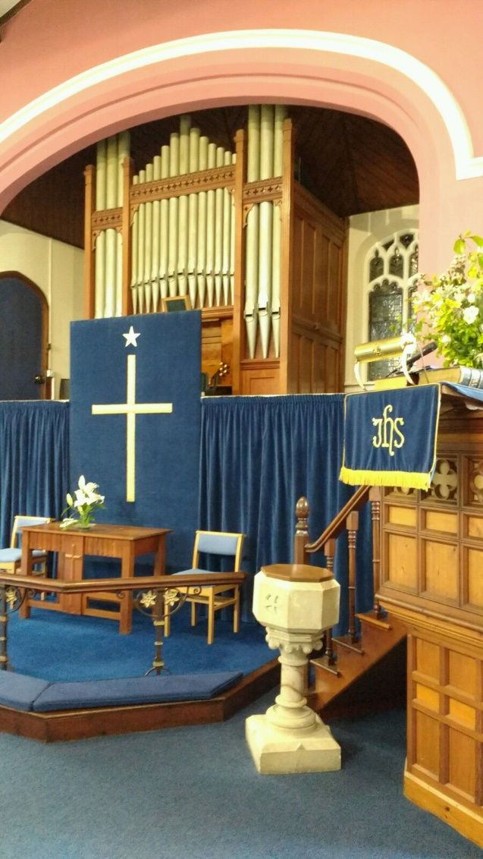
The restored Memorial Organ

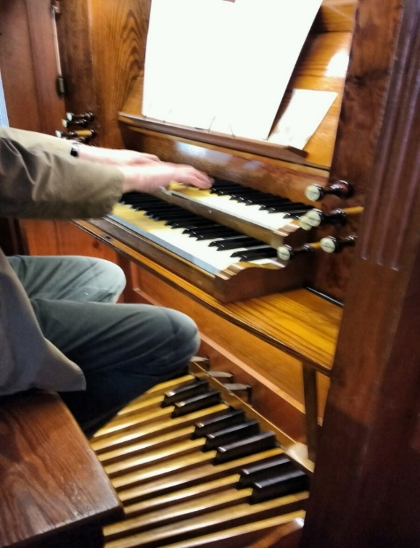
First playing of restored organ Easter 2019

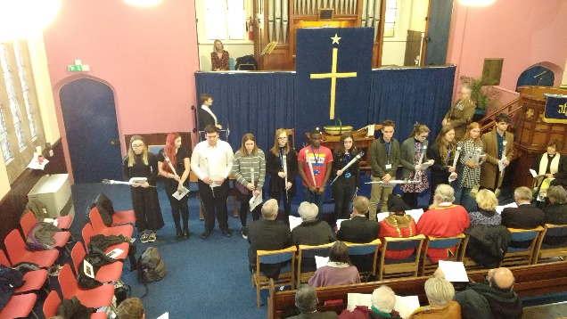
Presentation of flowers for the Fallen
Also showing Rev Helen Hollands, Rev Sam
Funnell, Major Philip Linehan and Alison Howard oboist who played Dido’s Lament with the organist

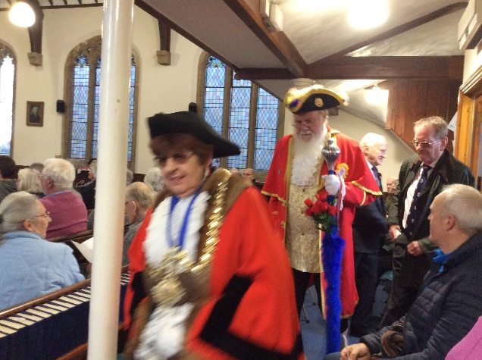
The Mayor and Town Cryer arrive for the Rededication Service

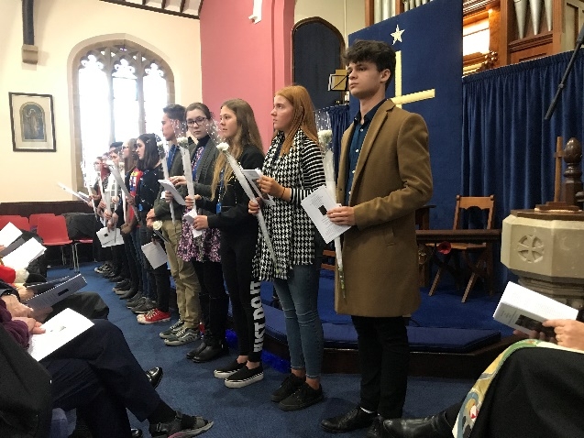
The twelve pupils of Homewood School each with a flower in remembrance of the Fallen

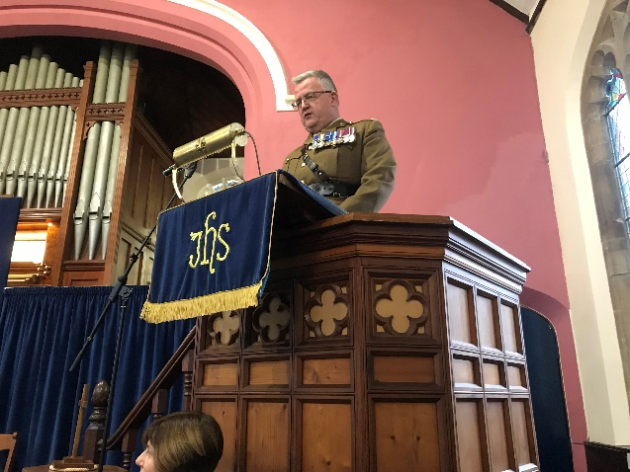
Major Linehan reads the researched details of the twelve Fallen as a flower is presented

General View
Tenterden Methodist-site of memorial organ
