St John’s Burlington Methodist Church, Bridlington – Three World War 1 Memorial Plaques
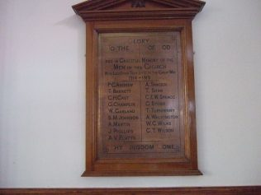 Plaque 1 appears to have come from The Quay Wesleyan Chapel, Chapel Street (now demolished)
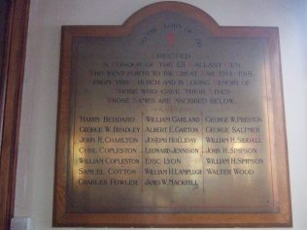 Plaque 2 lists the men from St. John’s Primitive Methodist Church, in St. John Street, (now the Coo-op) so it presumably came from there.
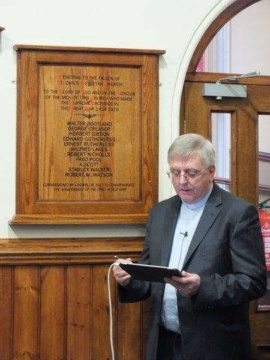

Plaque 3 Apparently, the original plaque (unveiled before 15th October 1921) was lost and was replaced in 2014. The following names are listed:
Walter Bootland
George Creaser
Herbert Gibson
Edward Gutherless
Ernest Gutherless
Wilfred Lakes
Robert Nicholls
Fred Pool
F. Scott (could be A Scott?)
Stanley Walker
Robert W. Watson
New WW1 MEMORIAL PLAQUE DEDICATION SERVICE

A short Dedication Service was held at the Church on Sunday, 26th January 2014, commencing at 11.30 am following the normal Church Service. Rev. Chris Free conducted both services. He commenced the second service by saying how, despite making thorough enquiries, no one knew the whereabouts of the lost memorial plaque which this new one replaced.
Present at both services was Miss Linda Ellis who had Commissioned the new plaque and there were also members representing various military associations –
S. M. Martin Barmby led the Bridlington Royal Navy Association together with 8 other members.
S. M. Martin Jolly of Bridlington Royal Navy Association led four Standard Bearers, Barry Moody of the Royal British Legion (Bridlington Association) of which there were 5 other members present together with David Hadfield of the Royal Engineers and Lance Corporal Karl Middleton of Bridlington Detachment Army Cadet Force, Yorkshire Regiment.
Also represented were Adult Instructors from Bridlington School Combined Cadet Force and Bridlington Detachment of the Army Cadet Force.
Barry Moody read the poem In Flanders Field and the Exhortation was given by Martin Barmby. Appropriately Rev Chris Free read the Bible reading, John Chapter 15, v 9-17, led prayers and Miss Linda Ellis read out the 11 names on the Plaque which was fixed to the Vestibule wall. The Last Post was sounded followed by the Standards being lowered to observe a two-minutes silence, concluding with Reveille being sounded.
Also present at the Dedication was Norman Ellis, the father of Linda, accompanied by Susan Storry. Both Norman and Linda are related to Stanley Walker whose name is on the plaque. Chris Bonnett, author of ‘Great War Heroes of Bridlington’ and Mike Wilson who contributed, were also present.
Both Services were enhanced by the presence of those representing the Associations and all enjoyed coffee and biscuits in the Church main hall when the Service was concluded with prayers from Rev. Chris Free.
